Trochaic Tetrameter

📏 What is Trochaic Tetrameter
# Source: AI Source: Provided by: [Data Path: Persons Table -> ID Column: 1, Name_En Column: Motasem Essam] -> From: [ChatGPT] on [8/2/2025]
Trochaic Tetrameter is a metrical pattern consisting of:
- Four trochees per line
- A trochee = a stressed syllable followed by an unstressed syllable
→ DUM-da DUM-da DUM-da DUM-da

🧱 Structure
# Source: AI Source: Provided by: [Data Path: Persons Table -> ID Column: 1, Name_En Column: Motasem Essam] -> From: [ChatGPT] on [8/2/2025]
- 8 syllables per line (4 trochees × 2 syllables)
- Rhythm: / × / × / × / ×
(/ = stressed, × = unstressed)

📝 Examples
# Source: AI Source: Provided by: [Data Path: Persons Table -> ID Column: 1, Name_En Column: Motasem Essam] -> From: [ChatGPT] on [8/2/2025]
Tell me not in mournful numbers
— Henry Wadsworth Longfellow
Tyger Tyger, burning bright
— William Blake

🔀 Variations & Flexibility
# Source: AI Source: Provided by: [Data Path: Persons Table -> ID Column: 1, Name_En Column: Motasem Essam] -> From: [ChatGPT] on [8/2/2025]
Trochaic tetrameter can include:
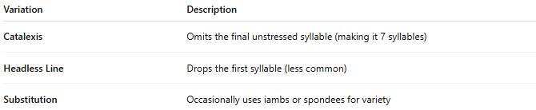
Variation | Description
Catalexis | Omits the final unstressed syllable (making it 7 syllables)
Headless Line | Drops the first syllable (less common)
Substitution | Occasionally uses iambs or spondees for variety

🧬 Poetic Use & Effect
# Source: AI Source: Provided by: [Data Path: Persons Table -> ID Column: 1, Name_En Column: Motasem Essam] -> From: [ChatGPT] on [8/2/2025]
- Has a driving, emphatic rhythm—often used for urgency or incantation
- Feels chant-like or hypnotic, common in ballads, hymns, and dramatic verse
- Unlike iambic patterns, it starts strong (with stress)

🏛️ Where It's Found
# Source: AI Source: Provided by: [Data Path: Persons Table -> ID Column: 1, Name_En Column: Motasem Essam] -> From: [ChatGPT] on [8/2/2025]
- Blake, Longfellow, and Poe often used this meter
- Popular in hymns, children’s poetry, and magical/ritualistic poetry
- Also appears in folk ballads and narrative verse

